


Exploiting and Defense  Dobin Rutishauser 2016, 2017, 2018
  Compass Security Schweiz AG | Tel +41 55 214 41 60
  Werkstrasse 20 | Fax +41 55 214 41 61
  Postfach 2038 | team@csnc.ch
  CH-8645 Jona | www.csnc.ch

Intro
  Compass Security Schweiz AG | Tel +41 55 214 41 60
  Werkstrasse 20 | Fax +41 55 214 41 61
  Postfach 2038 | team@csnc.ch
  CH-8645 Jona | www.csnc.ch



About Me

Dobin Rutishauser
Working as Security Analyst @ Compass Security
✦ Penetration Tests
✦ Webapp Checks
✦ Architecture Reviews
✦ & lots more
Interested in Hacking Security since a young age (1998+)
© Compass Security Schweiz AG www.csnc.ch Slide 3

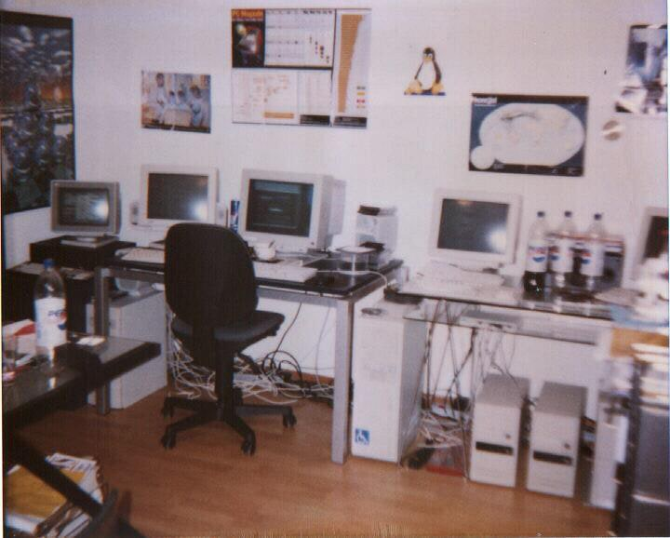
I got a bit overboard when I was little | Slide 4

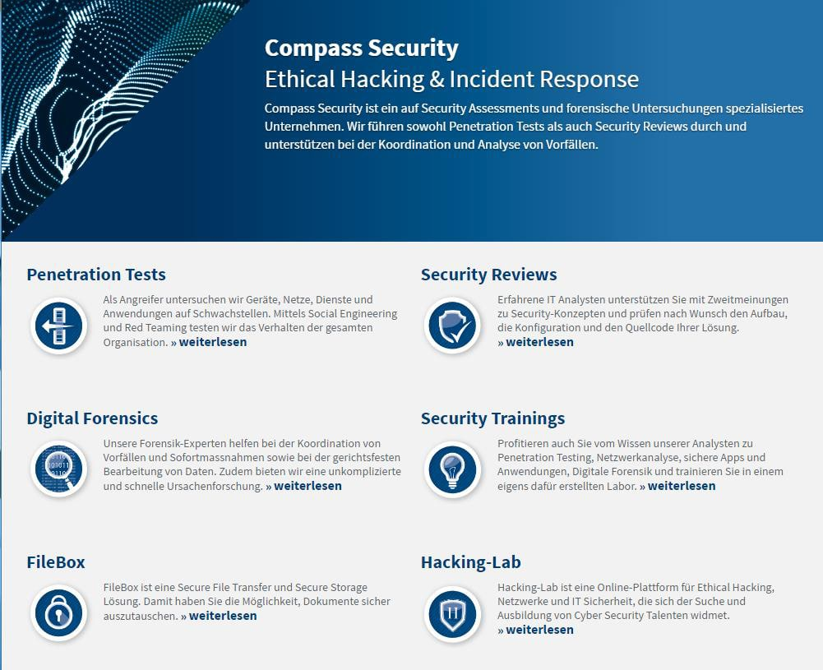
Compass | Slide 5

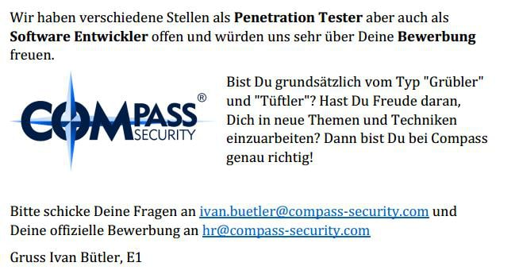
Compass is hiring (always)

© Compass Security Schweiz AG www.csnc.ch Slide 6

Content
  Compass Security Schweiz AG | Tel +41 55 214 41 60
  Werkstrasse 20 | Fax +41 55 214 41 61
  Postfach 2038 | team@csnc.ch
  CH-8645 Jona | www.csnc.ch

Content

Exploit & Defense
We will write exploits to exploit buffer-overflows
We will analyze what defenses exist to make writing exploits harder
© Compass Security Schweiz AG www.csnc.ch Slide 8

Lecture
  Compass Security Schweiz AG | Tel +41 55 214 41 60
  Werkstrasse 20 | Fax +41 55 214 41 61
  Postfach 2038 | team@csnc.ch
  CH-8645 Jona | www.csnc.ch

Lecture

Website:
https://exploit.courses
✦ Online exploit development website
✦ Access to your own Linux via JavaScript terminal
✦ Uses Hacking-Lab accounts
✦ Solve challenges online
✦ Write exploits
✦ Debug stuff
https://www.hacking-lab.com
✦ Half-online challenges website
✦ Uses HLCD (Kali-based Linux Distribution)
✦ VPN-Based
✦ Use this if you don’t like exploit.courses
© Compass Security Schweiz AG www.csnc.ch Slide 10


Lecture
Siiiiii abr ähhhhh
EBP isch doch 32 bit?
© Compass Security Schweiz AG www.csnc.ch Slide 12

Motivation  Motivation for Exploiting & Defense
  Compass Security Schweiz AG | Tel +41 55 214 41 60
  Werkstrasse 20 | Fax +41 55 214 41 61
  Postfach 2038 | team@csnc.ch
  CH-8645 Jona | www.csnc.ch

Motivation

For the hacker:
✦ Develop exploits
✦ Debugging of C/C++ code
✦ Disassembly & reversing of assembler code
✦ Being 31337
For the Sysadmin
✦ Judge security level of operating systems, and applications
✦ Harden and protect servers, clients
For the CISO:
✦ Assess CVSS scores
✦ Assess (new) security mitigations
✦ Better risk analysis
© Compass Security Schweiz AG www.csnc.ch Slide 14

Motivation

For everyone:
✦ How do functions work?
✦ How does the memory allocator work?
✦ What’s the difference between userspace and kernelspace?
✦ How does computer work?!
© Compass Security Schweiz AG www.csnc.ch Slide 15

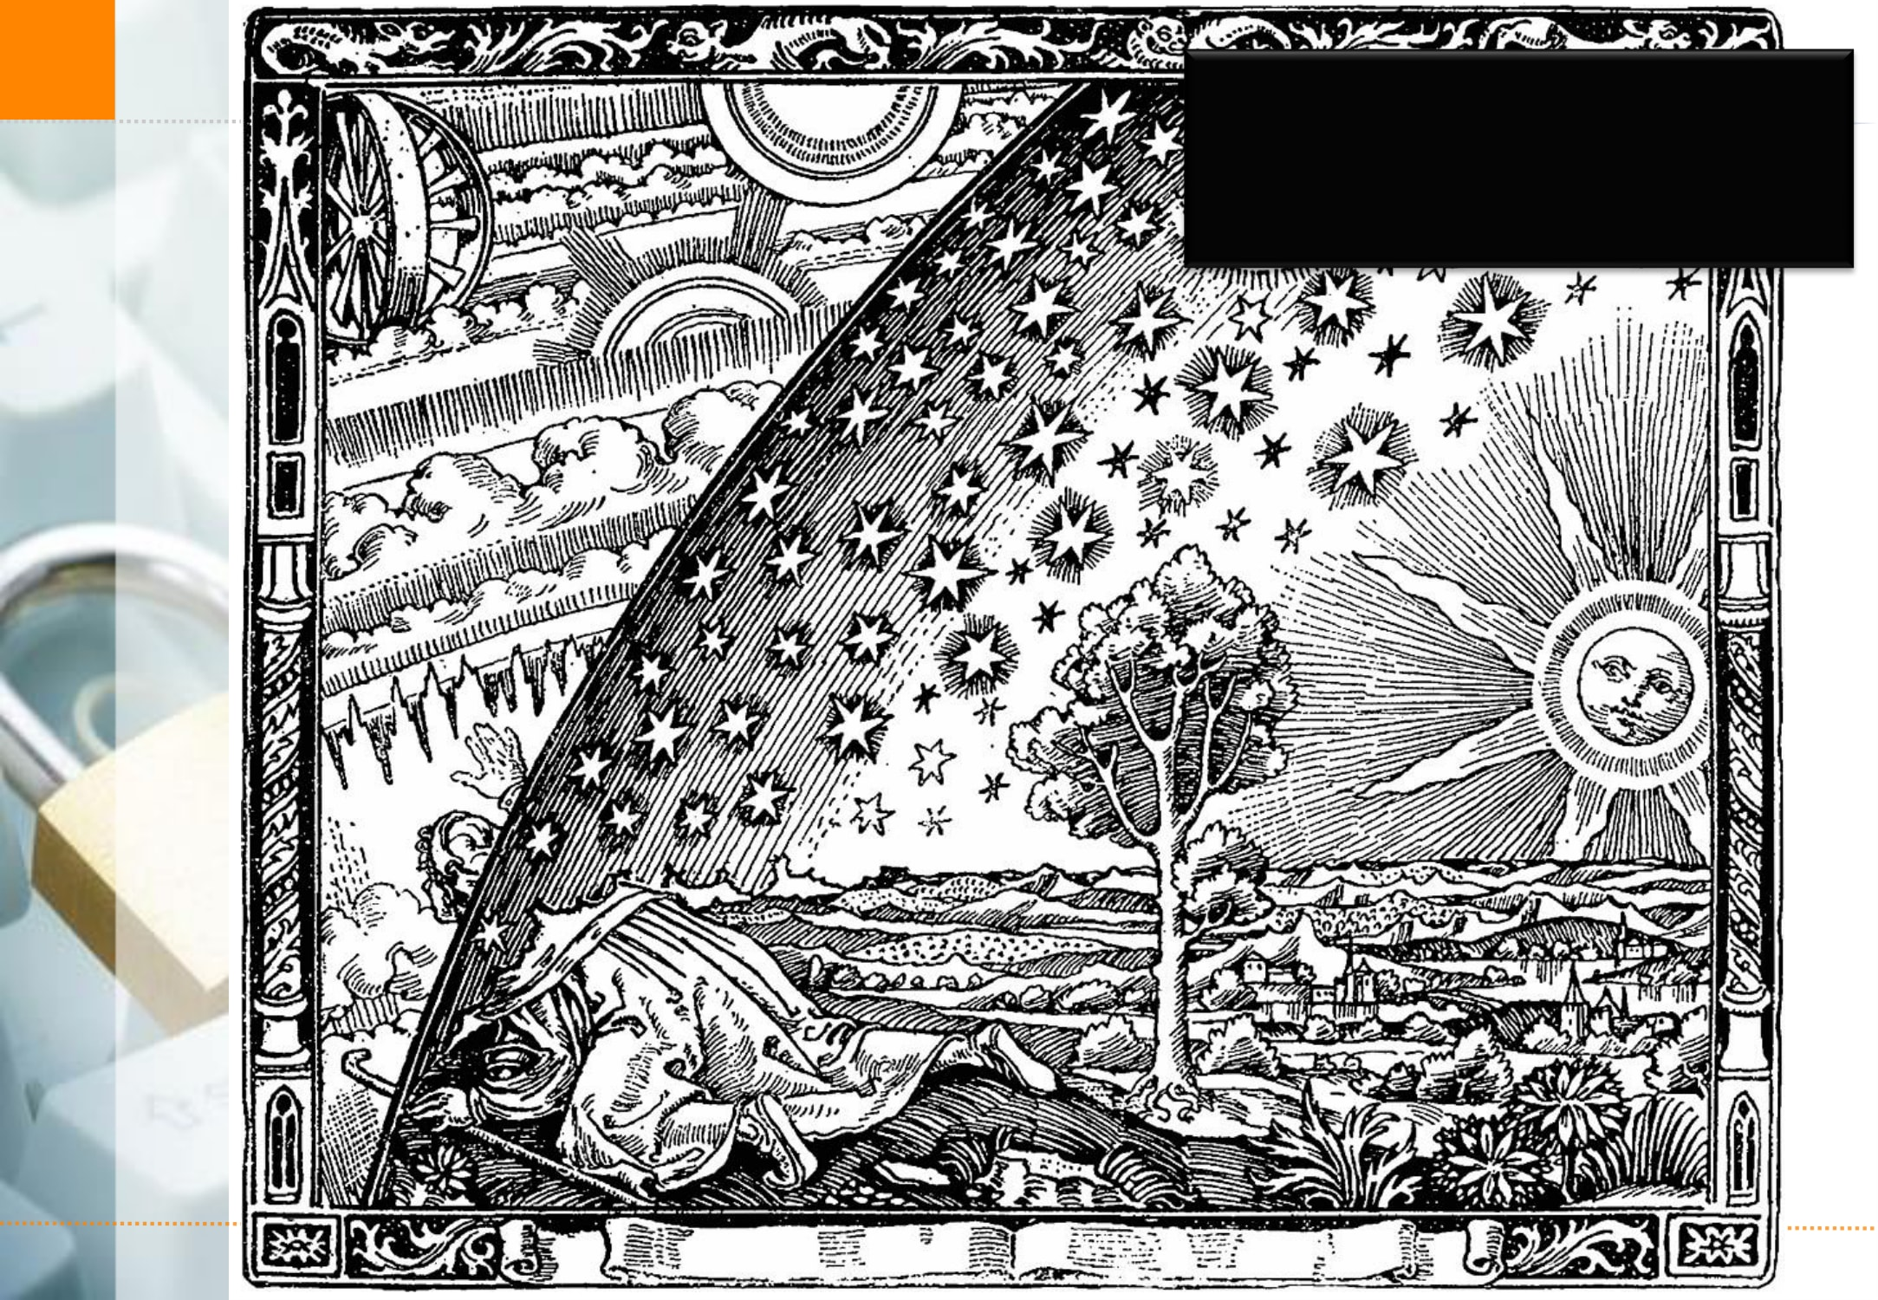
Looking behind the curtain
Slide 16

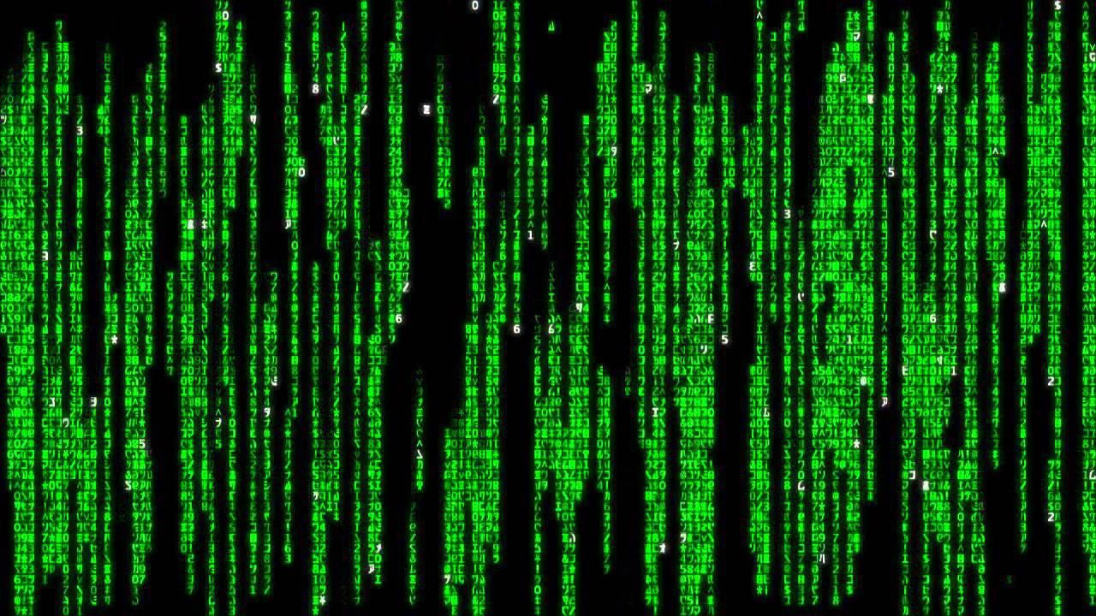
Motivation

© Compass Security Schweiz AG www.csnc.ch Slide 17

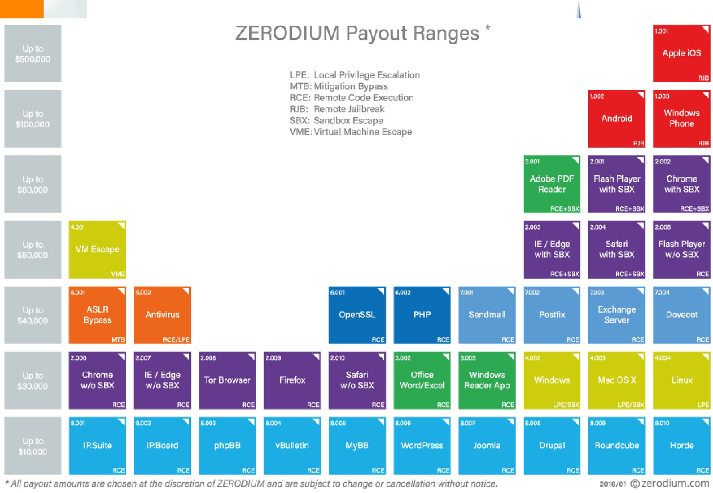

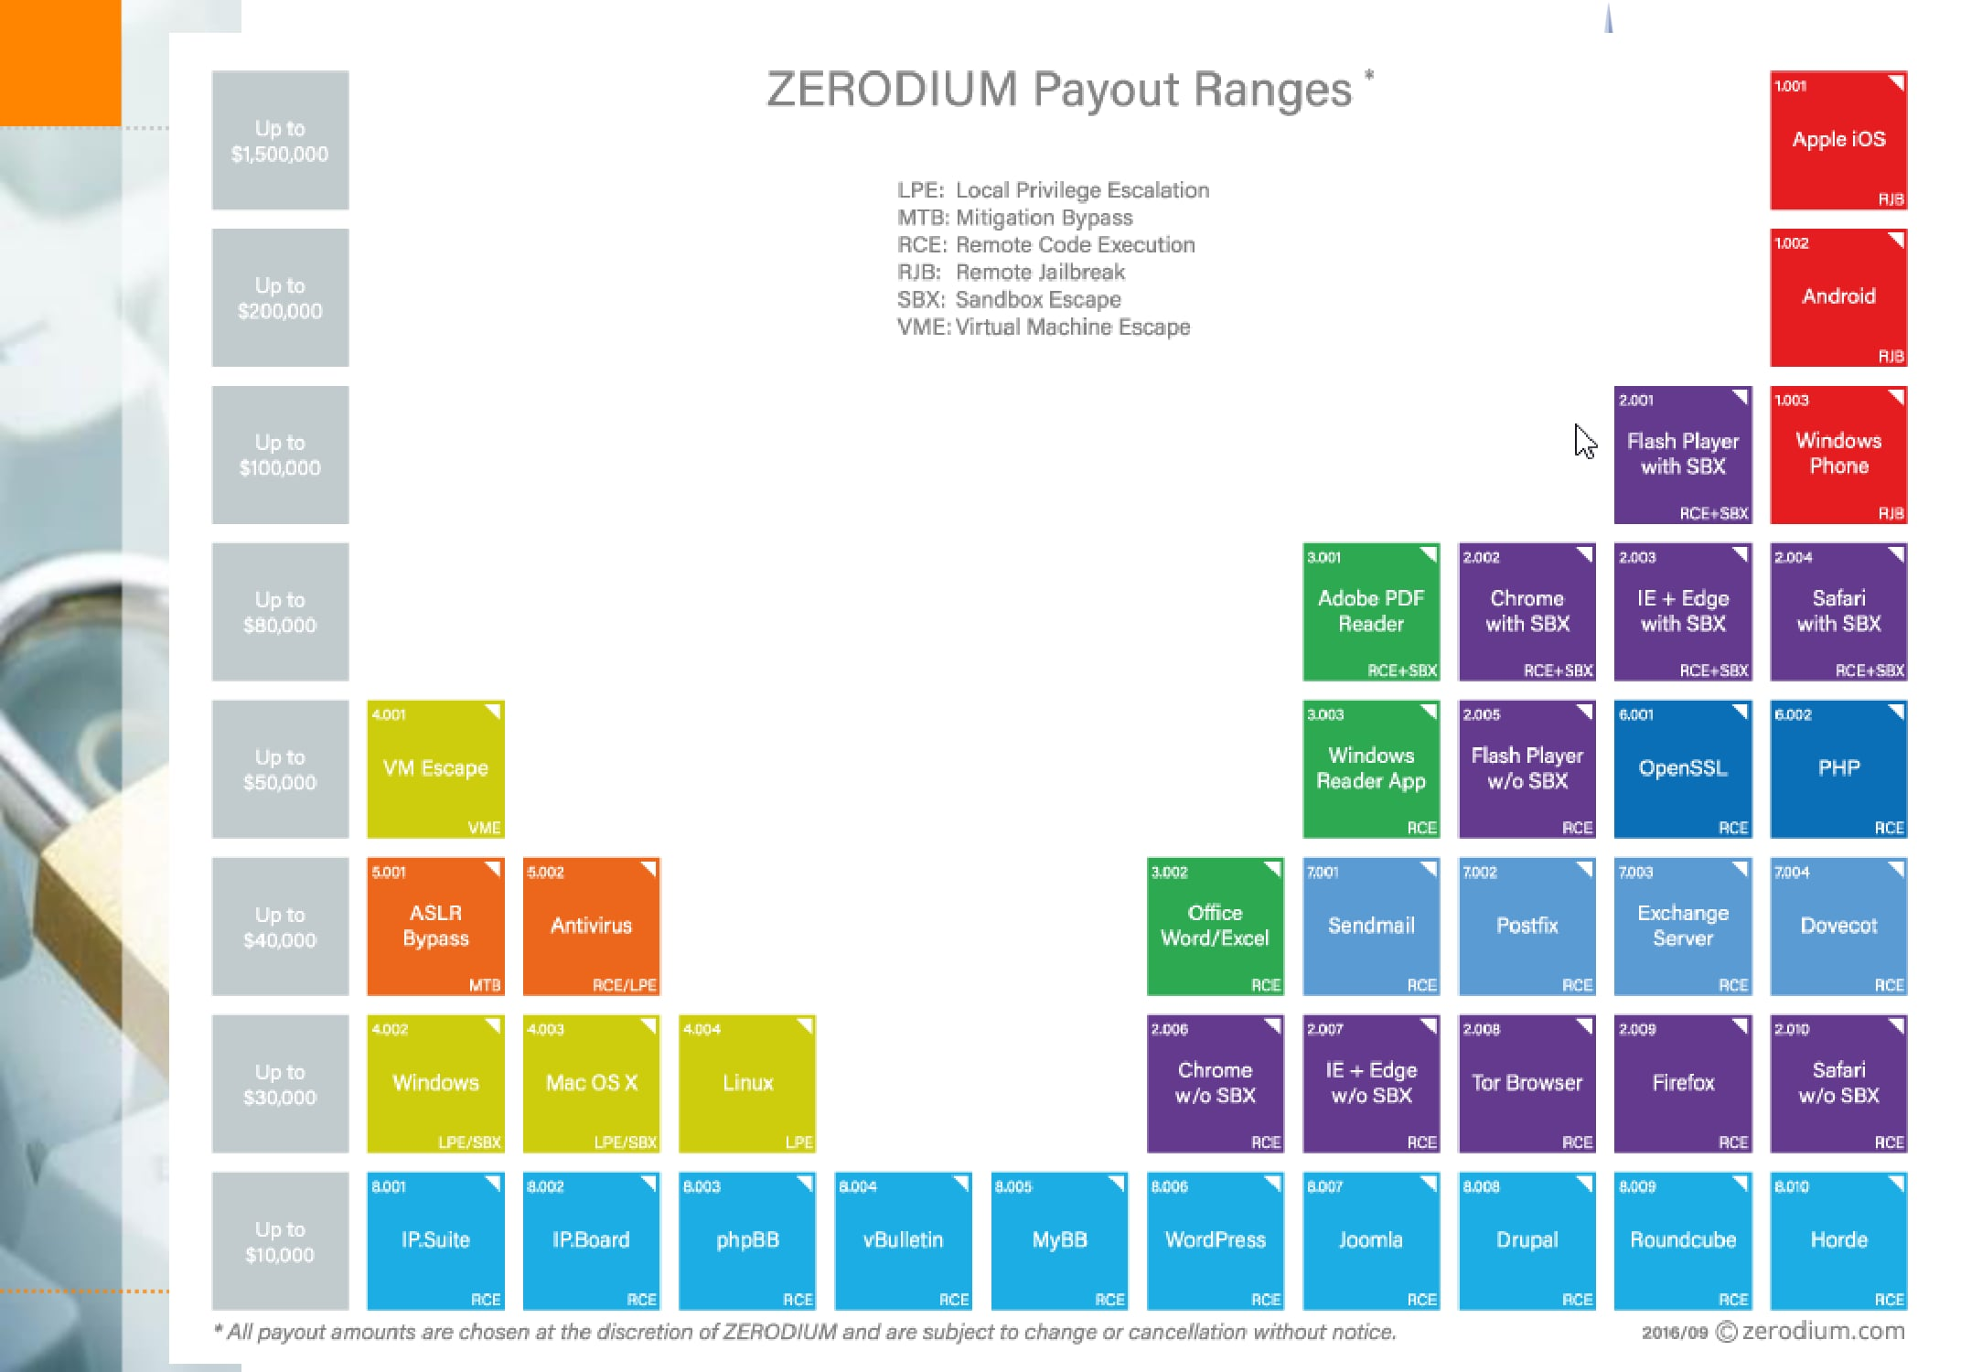

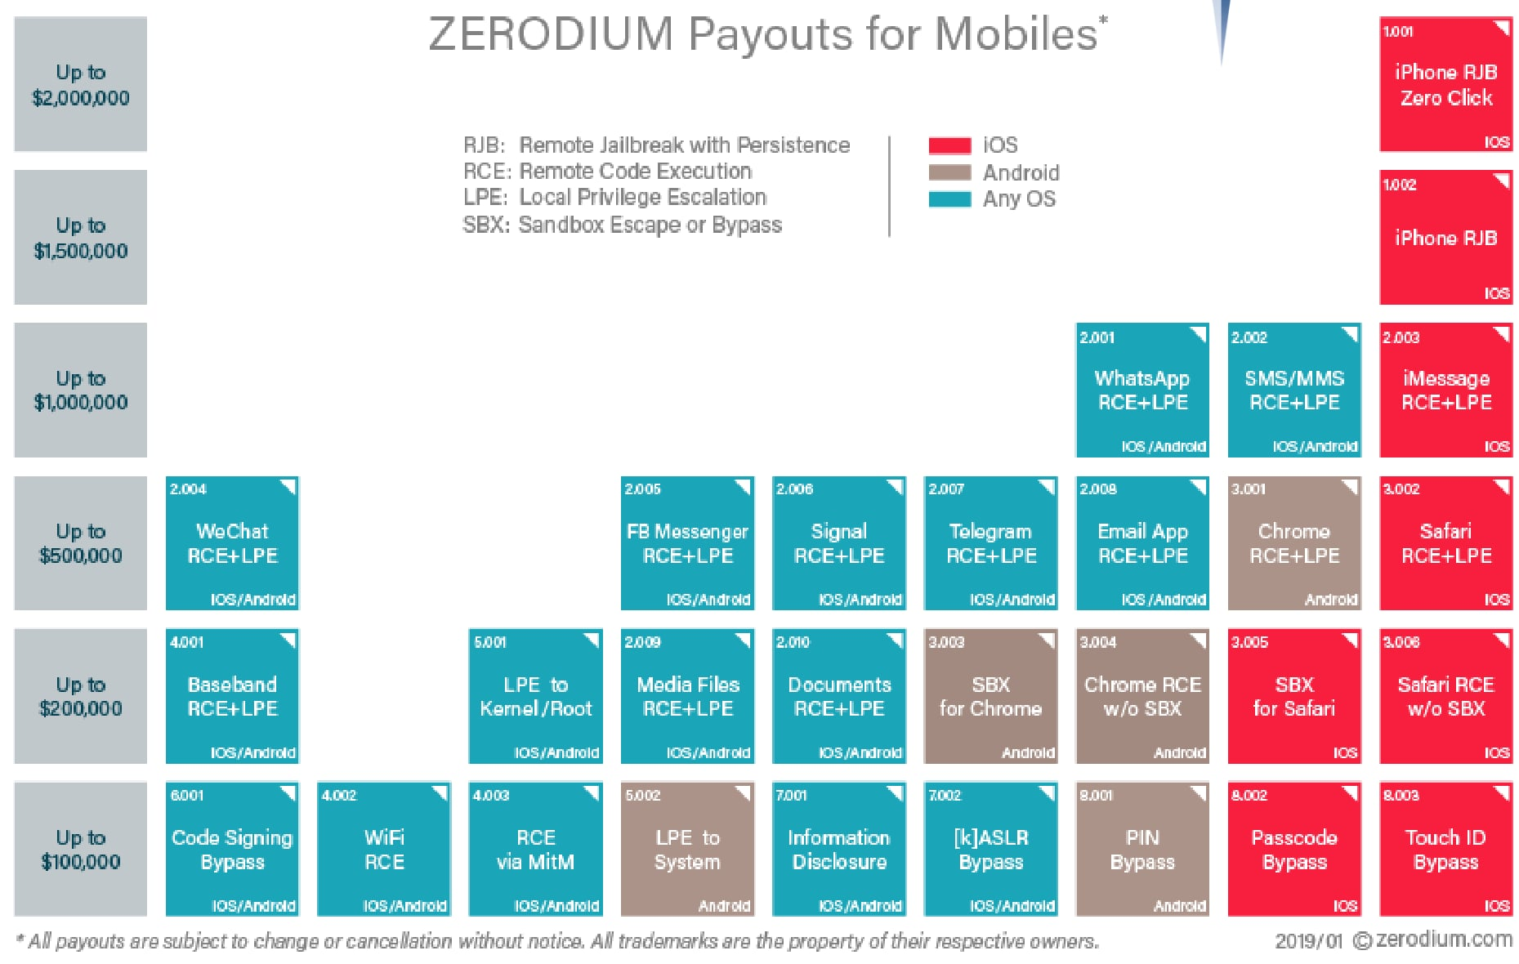

© Compass Security Schweiz AG www.csnc.ch Slide 20

Content of the next 8 Friday afternoons

Compass Security Schweiz AG | Tel +41 55 214 41 60
Werkstrasse 20 | Fax +41 55 214 41 61
Postfach 2038 | team@csnc.ch
CH-8645 Jona | www.csnc.ch

Content

You want to learn:
✦ What memory corruptions are
✦ What buffer overflows are
✦ What exploits are
✦ How exploits are being created
✦ To exploit a local application
✦ To exploit a remote application
✦ Learn about anti-exploiting technologies
✦ To circumvent all common anti-exploiting technologies for Linux
✦ See how Windows does it
✦ Use Use-After-Free
✦ Hack browsers
✦ Hack facebook “for a friend”
© Compass Security Schweiz AG www.csnc.ch Slide 22

Content

You will actually learn:
✦ Intel x86
✦ Architecture
✦ CPU
✦ Registers
✦ Linux
✦ Userspace memory layout, stacks, heap
✦ Syscalls
✦ Sockets
✦ Networking
✦ Programming Languages
✦ Assembler
✦ C
✦ Python
✦ Bash
© Compass Security Schweiz AG www.csnc.ch Slide 23

Plan
  Compass Security Schweiz AG | Tel +41 55 214 41 60
  Werkstrasse 20 | Fax +41 55 214 41 61
  Postfach 2038 | team@csnc.ch
  CH-8645 Jona | www.csnc.ch

Plan

29.03.2019
Theory:
✦ 0x01 Intro (this)
✦ 0x02 Intro Technical
✦ 0x10 Intel Architecture
✦ 0x11 Memory Layout
Challenges:
✦ 0: Introduction to memory layout - basic
✦ 1: Introduction to memory layout - advanced
© Compass Security Schweiz AG www.csnc.ch Slide 25

Plan

05.04.2019
Theory:
✦ 0x12 C Array and Data Structures
✦ 0x30 Assembler Intro
✦ 0x31 Shellcode
✦ 0x32 Function Call Convention
✦ 0x33 Debugging
Challenges:
✦ 2: C buffer analysis - simple
✦ 3: Introduction to shellcode development
✦ 7: Function Call Convention in x86 (32bit)
✦ 8: C buffer analysis - with debugging
✦ 9: Simple Buffer overflow - variable overwrite
© Compass Security Schweiz AG www.csnc.ch Slide 26

Plan

12.04.2019
Theory:
✦ 0x41 Buffer Overflow
✦ 0x42 Exploit
✦ 0x44 Remote Exploit
Challenges:
✦ 11: Development of a buffer overflow exploit - 32 bit
✦ 12: Development of a buffer overflow exploit - 64 bit
✦ 13: Development of a remote buffer overflow exploit - 64 bit
© Compass Security Schweiz AG www.csnc.ch Slide 27

Plan

26.04.2019
Theory:
✦ 0x51 Exploit Mitigation
✦ 0x52 Defeat Exploit Mitigation
✦ 0x53 Exploit Mitigation – PIE
✦ 0x54 Defeat Exploit Mitigation ROP
Challenges:
✦ 14: Stack canary brute force
✦ 15: Simple remote buffer overflow exploit - ASLR/DEP/64bit
✦ 16: Remote buffer overflow with ROP - DEP/64bit
✦ 17: Remote buffer overflow with ROP - DEP/ASLR/64bit
© Compass Security Schweiz AG www.csnc.ch Slide 28

Plan

03.05.2019
Theory:
✦ 0x55: Defeat Exploit Mitigation – Heap Intro
✦ 0x56: Defeat Exploit Mitigation – Heap Attacks
Challenges:
✦ 31: Heap use-after-free analysis
© Compass Security Schweiz AG www.csnc.ch Slide 29

Plan

10.05.2019
Theory:
✦ 0x60: Windows Exploiting
✦ 0x70: Secure Coding
✦ 0x71: Fuzzing
Challenges:
✦ 60: Linux Hardening
© Compass Security Schweiz AG www.csnc.ch Slide 30

Plan

17.05.2017
Theory:
✦ 0x72: Linux Hardening
✦ 0x73: Kernel Exploitation
✦ 0x74: Hardware Hacking
© Compass Security Schweiz AG www.csnc.ch Slide 31

Plan

24.05.2017
Theory:
✦ Puffer
✦ Case Studies
✦ Questions
© Compass Security Schweiz AG www.csnc.ch Slide 32

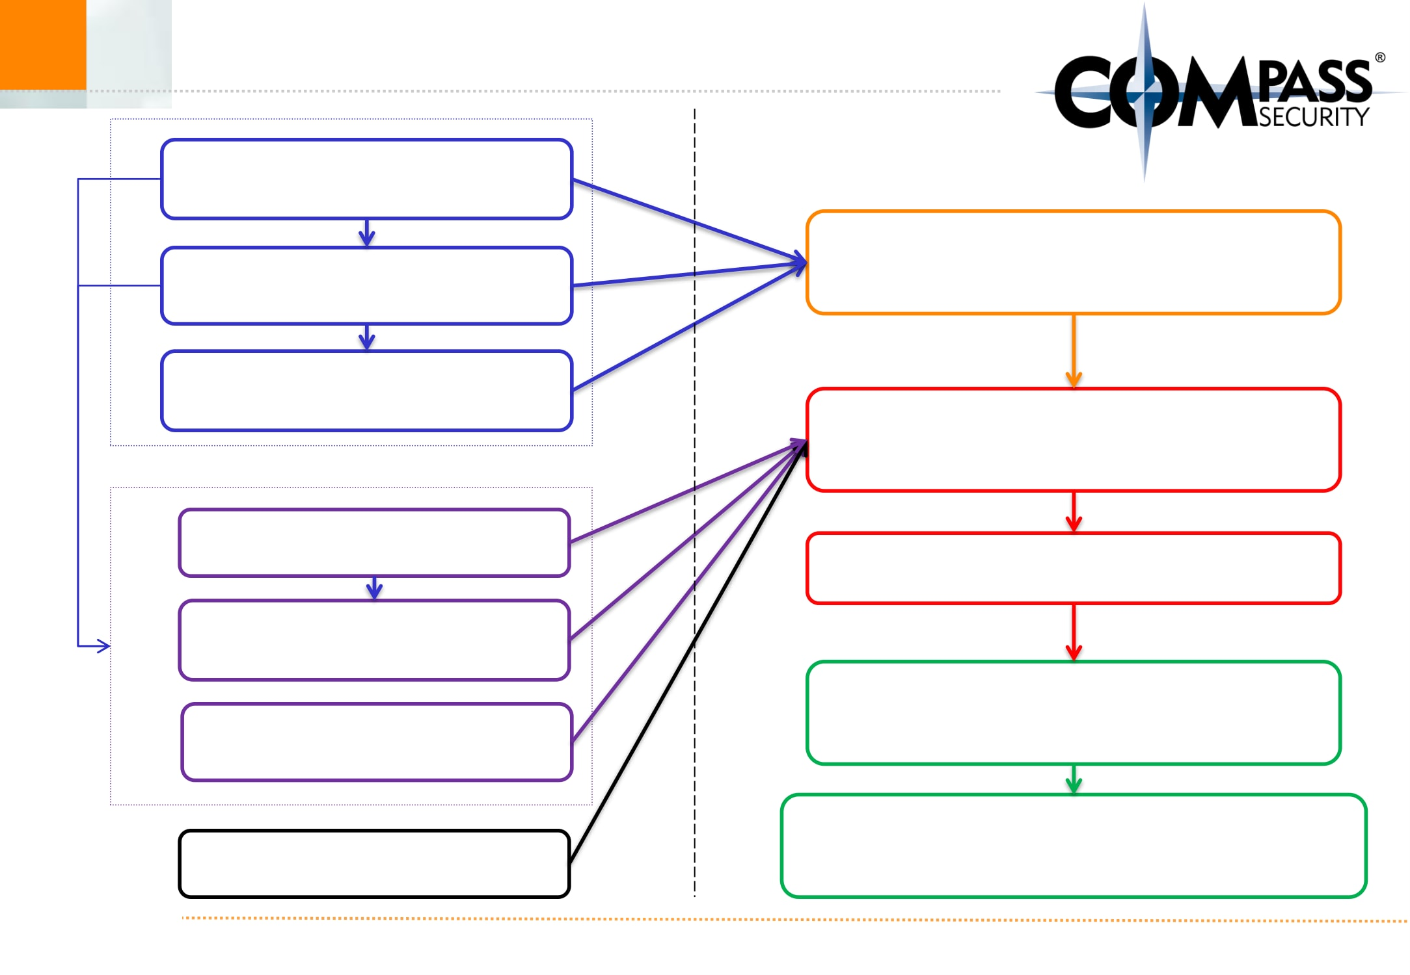
Content  Intel Architecture  Memory Layout  C Arrays  Assembler  Shellcode | Buffer Overflow  BoF Exploit  Remote Exploit

Function Calls  Debugging  © Compass Security Schweiz AG | Exploit Mitigations  Defeat Exploit Mitigations  www.csnc.ch Slide 33

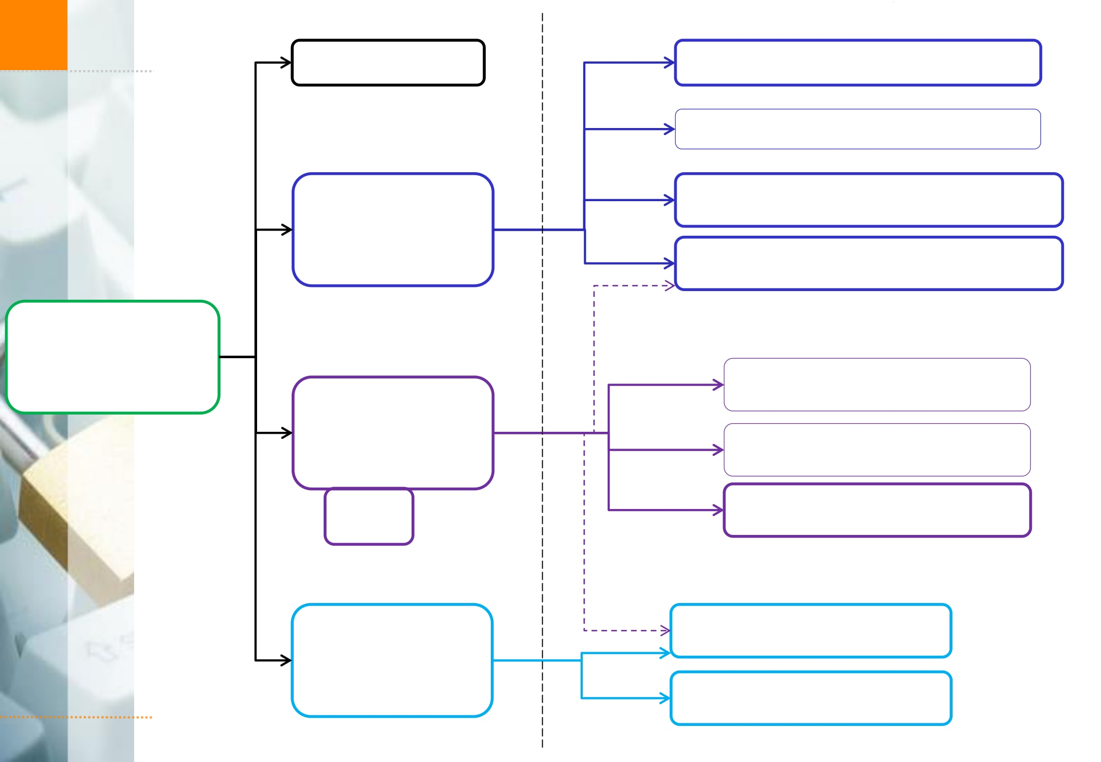
Exploit Mitigations | ASCII Armor  Stack  Canary  ASLR  PIE  DEP | Arbitrary Write  Overflow Local Vars  Heap Overflows  Brute Force  Partial RIP Overwrite  NOP Slide  Info Disclosure  Ret 2 PLT  ROP

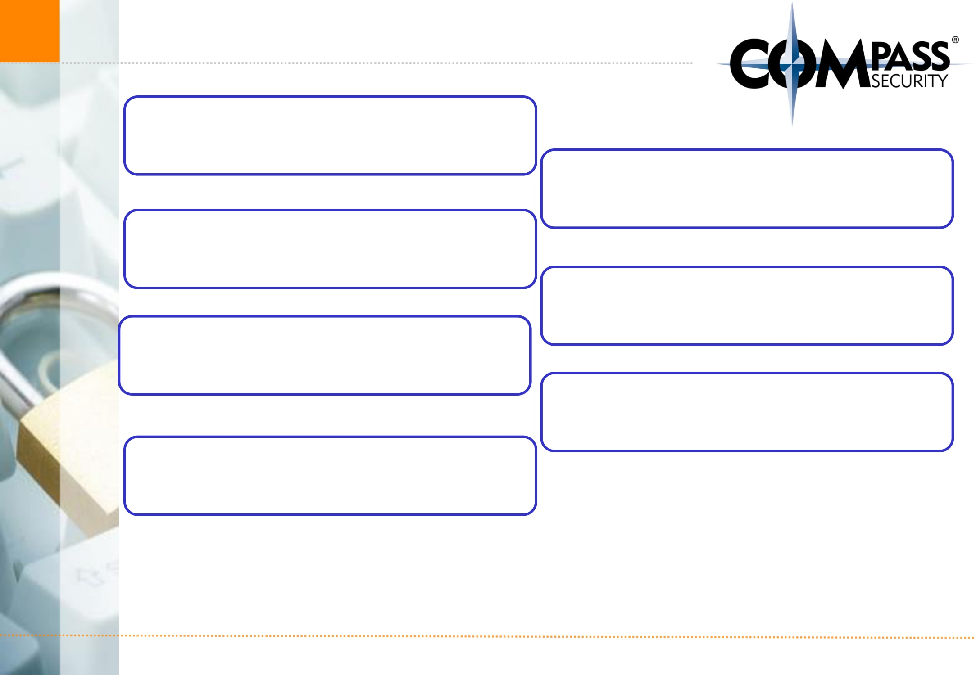
And:  Windows Exploiting  Fuzzing  Browser Security  Kernel Exploits | Secure Coding  Linux Hardening  Case Studies
© Compass Security Schweiz AG www.csnc.ch Slide 35

Exam Oral

What is (mainly) relevant for the oral exam?
✦ How does memory corruption work?
✦ How does an exploit work?
✦ What exploit mitigations exist?
✦ How can these exploit mitigations be circumvented?
More theoretical, not so much the nitty gritty details
Typical question:
✦ Explain me how a buffer overflow exploit works
✦ Now we introduce ASLR. What do you need to change?
© Compass Security Schweiz AG www.csnc.ch Slide 36

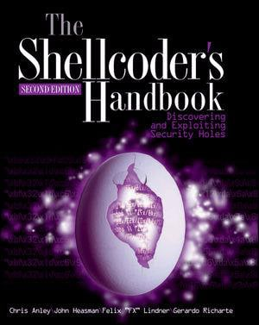
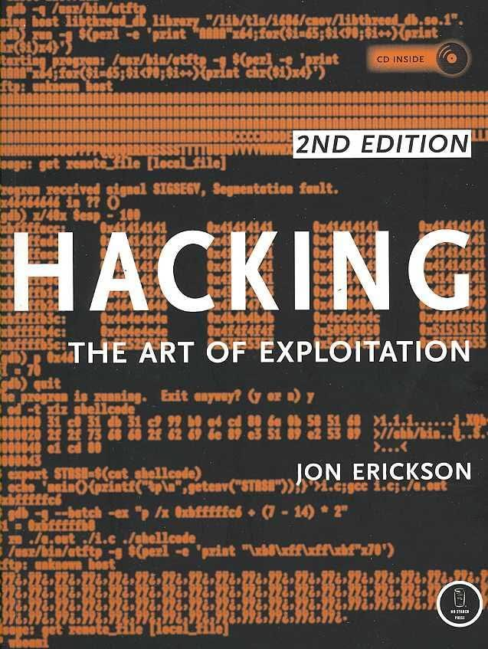
Books

© Compass Security Schweiz AG Slide 37

Legal Issue
  Compass Security Schweiz AG | Tel +41 55 214 41 60
  Werkstrasse 20 | Fax +41 55 214 41 61
  Postfach 2038 | team@csnc.ch
  CH-8645 Jona | www.csnc.ch

Legal CH

Don’t hack other people’s systems
«Damit der Tatbestand des strafbaren Hackens erfüllt ist, müssen folgende Voraussetzungen kumulativ erfüllt sein:
✦ Eindringen in das Datenverarbeitungssystem;
✦ fremdes Datenverarbeitungssystem;
✦ Eindringen auf dem Weg der von Datenübertragungseinrichtungen;
✦ besondere Sicherung gegen Zugriff.
https://www.lexwiki.ch/hacken/
© Compass Security Schweiz AG www.csnc.ch Slide 39


Legal International

Wassenaar
✦ Arms Control Treaty
✦ Anti-proliferation of Nukes and stuff
✦ Includes now (?):
✦ Intrusion malware
✦ Intrusion exploits
✦ IP surveillance
✦ -> Exploits are now weapons…
✦ Not allowed to transport over the border
✦ Exception: If they are open source
✦ (stop selling 0-days to Chinese gov!)
http://blog.erratasec.com/2015/05/some-notes-about-wassenaar.html
© Compass Security Schweiz AG www.csnc.ch Slide 40

